General Information for Certificate of Clearance or Activity Supervisor Clearance Certificate
The Commission on Teacher Credentialing requires that all candidates in professional prepartion programs complete a background check which includes fingerprinting through the FBI and DOJ prior to placement in student teaching or fieldwork. This is done by completing an application for a Certificte of Clearance.
Many school districts will require this same type of background check that includes fingerprinting through the FBI and DOJ for athletic trainers, coaches or other volunteers. This is done by completing an application for the Activity Supervisor Clearance Certificate.
Candidates who hold a teaching or services credential or 30 day sub permit or other document issued by the Commission on Techer Credentialing are not required to complete this process.
If you have questions call the Credential & Student Support office at 714-628-2735 or email Maria Lynch at mmlynch@chapman.edu.

Application process
Submit fingerprints electronically to the Commission on Teacher Credentialing by completing the LiveScan Fingerprint request and having your fingerprints taken at the Orange County Office of Education in Costa Mesa. (200 Kalmus Drive, Costa Mesa CA 92628, 714) 966-4306)
Complete the Online Direct Application on the Commission on Teacher Credentialing Website. (www.ctc.ca.gov)
Follow the steps outlined below
Step 1 – Go to www.ctc.ca.gov

Step 2 - Click on Online Applications and Status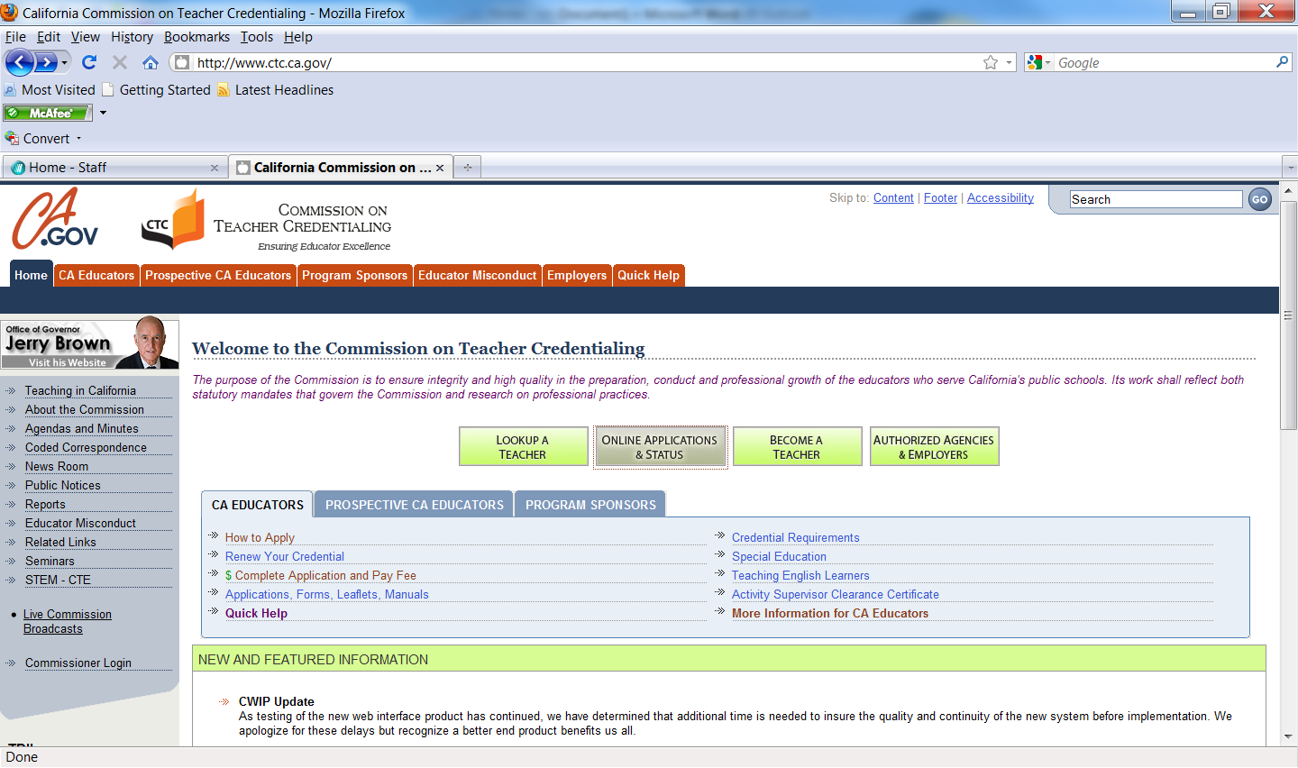s

Step 3 – Click on Apply for New Credential, Certificate of Permit
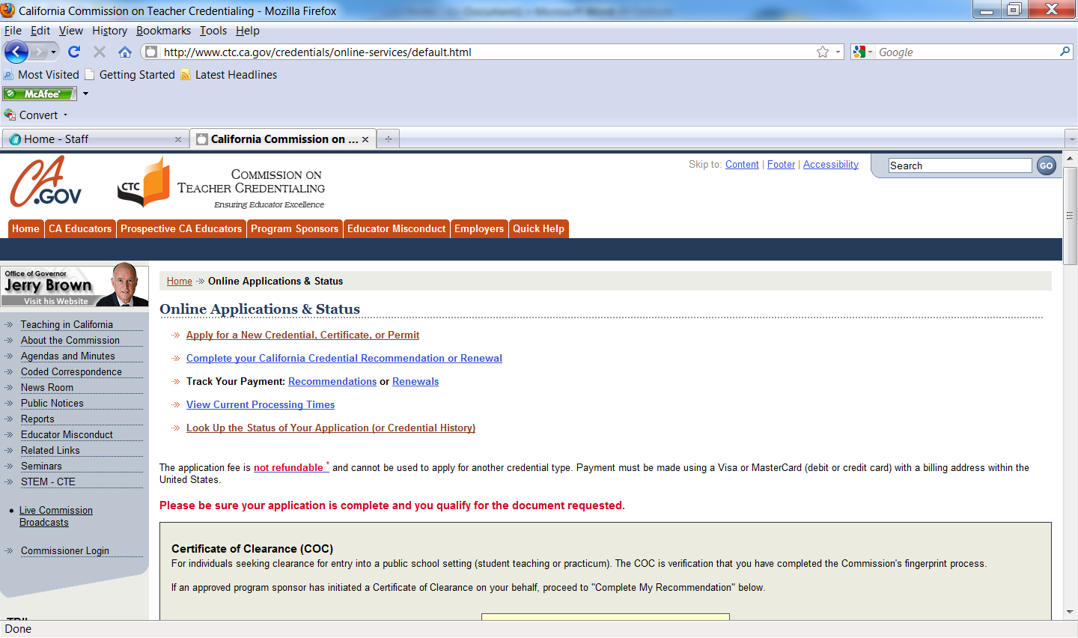
Step 4 Select which Document you are applying for: Athletic Training students will select Activity Supervisor Clearance Certificate, all other will check Certificate of Clearance

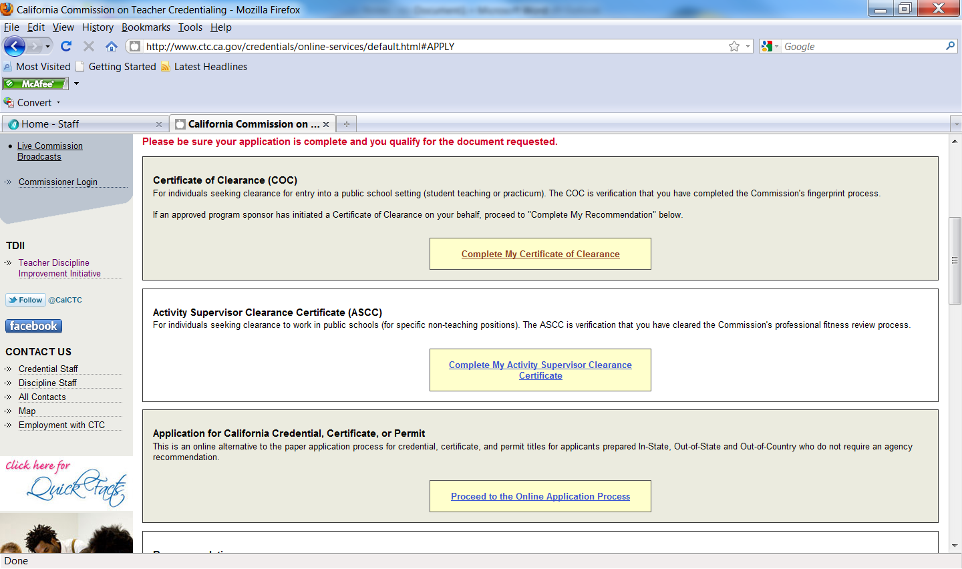

ATHLETIC TRAINING STUDENTS
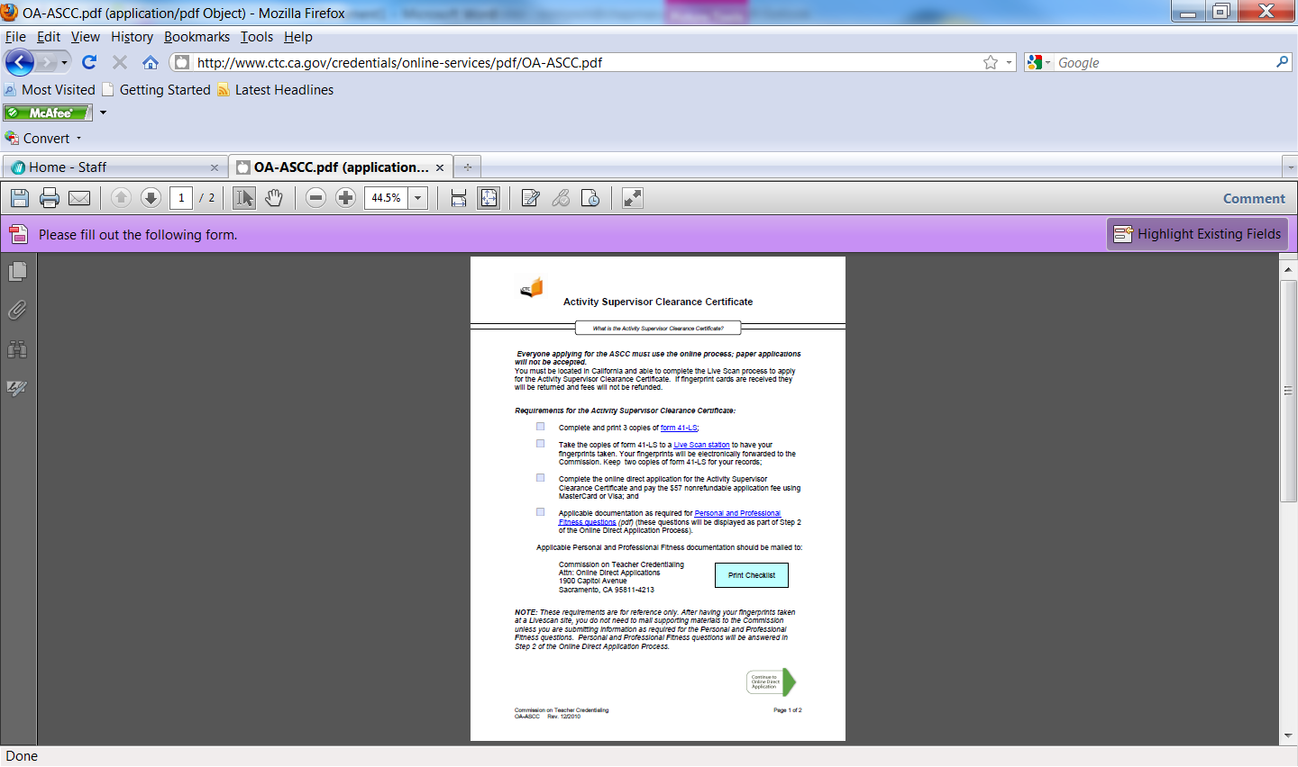
ALL OTHER STUDENTS
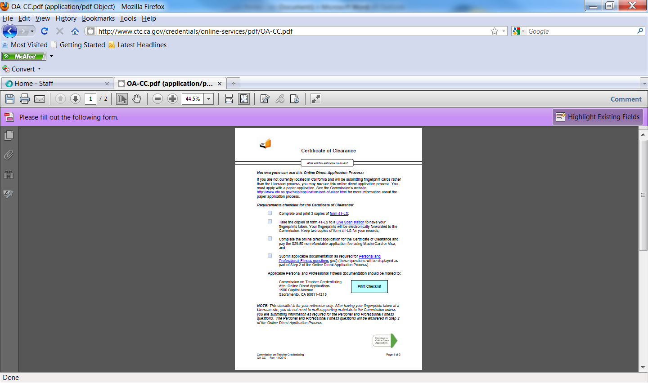

Step 5 Print the Checklist

Step 6 Click on the Green Arrow at the bottom of the page
Step 7 Complete the Application

